1. 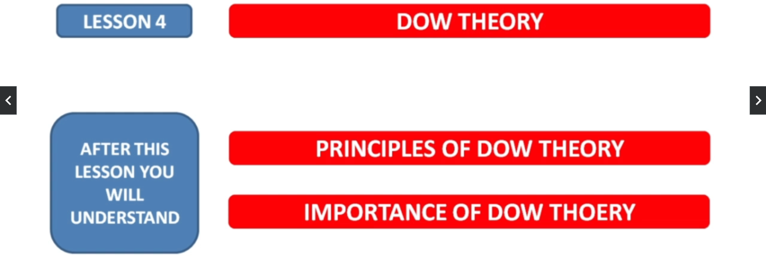
2. 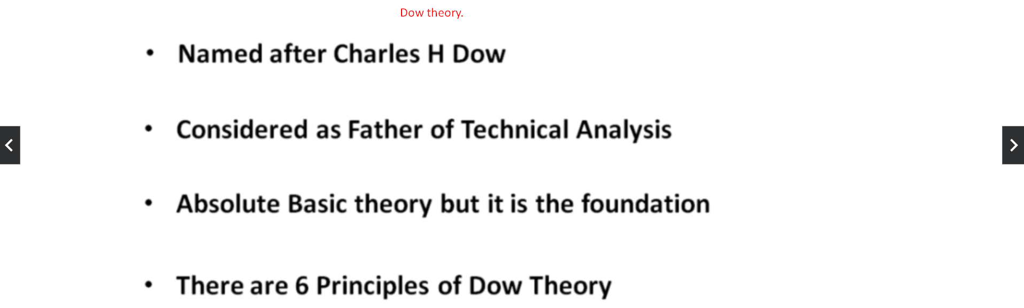
3. 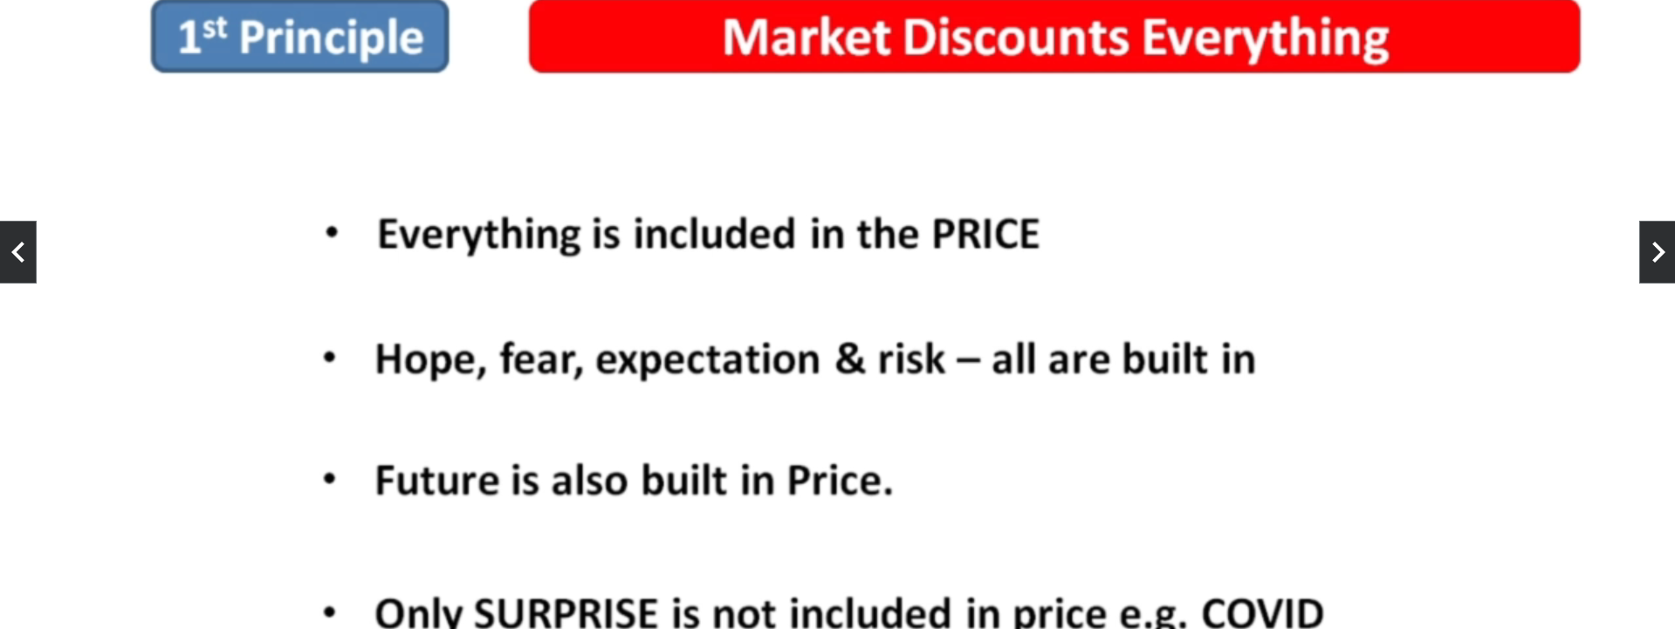
4. 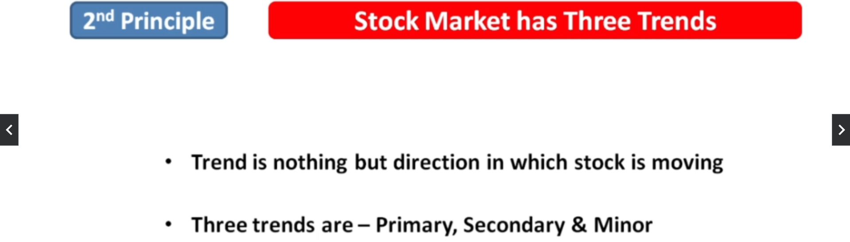
5. 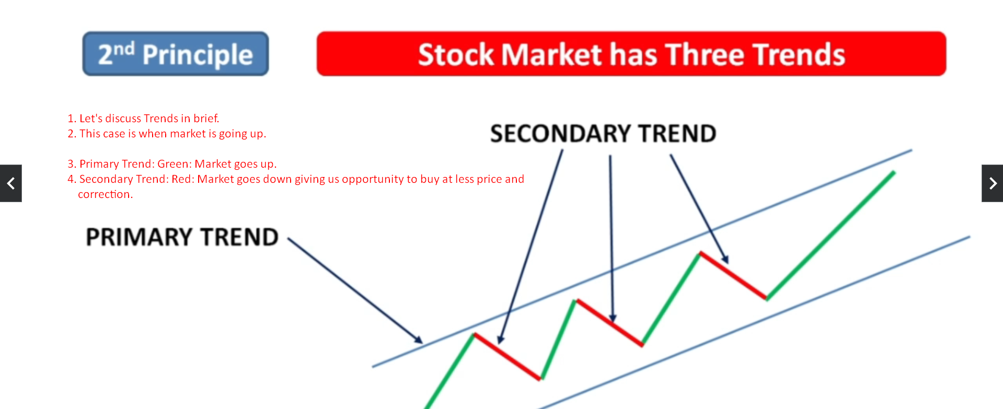
6. 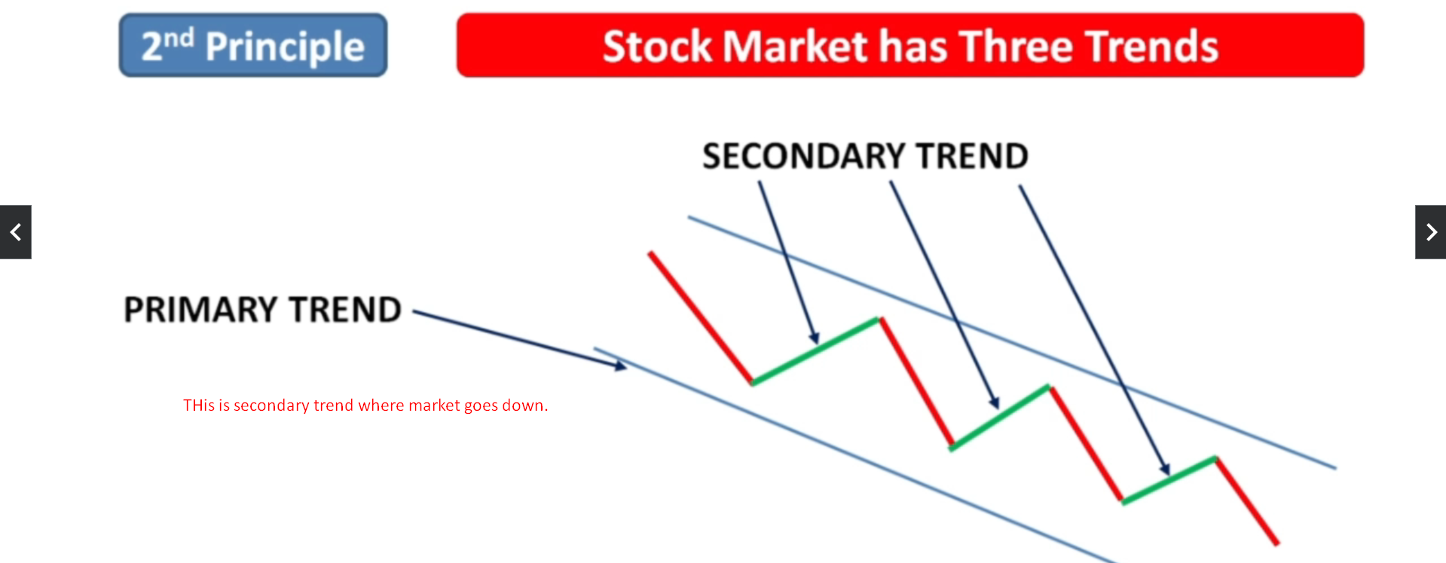  
   In secondary trend, stock gets costly before going down.
7. 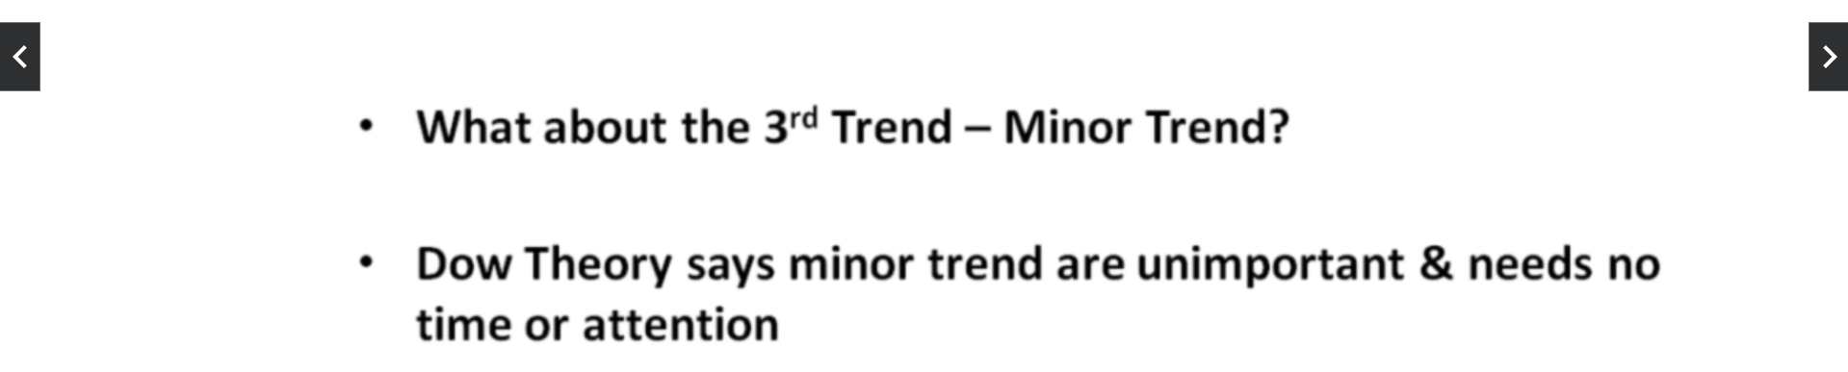
8. 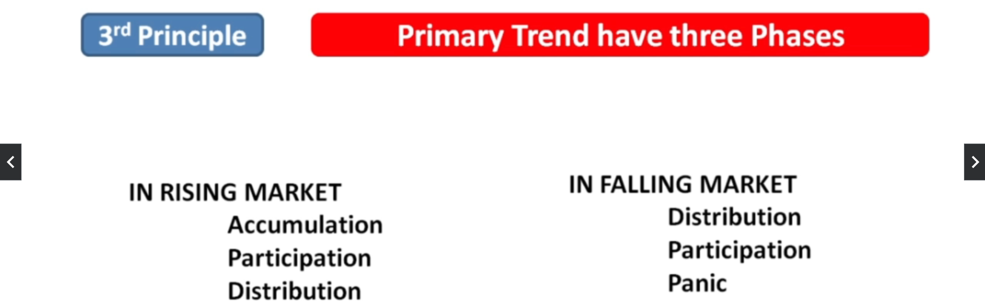
9. Accumulation: People begin to buy.   
   Participation: People buy rapidly and market goes up.  
   Distribution: Market remains flat or falls down
10. 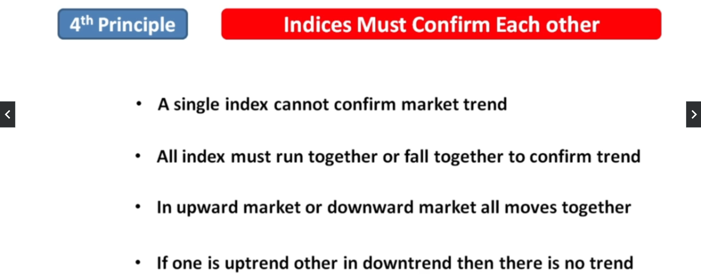
11. 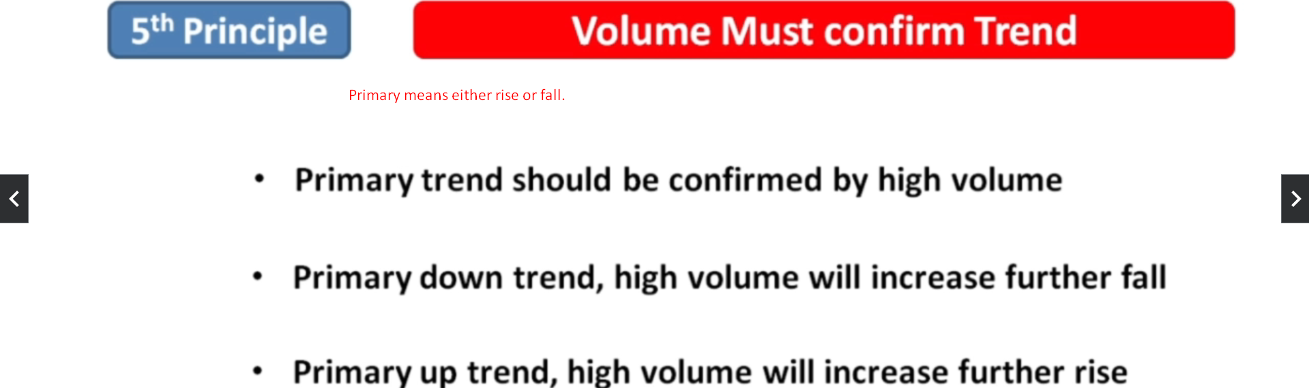
12. 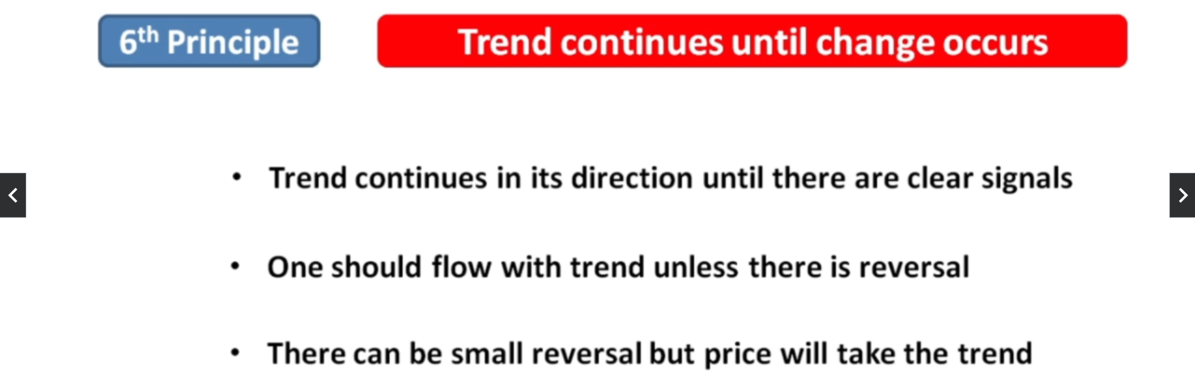
13. 